Just after startup.  
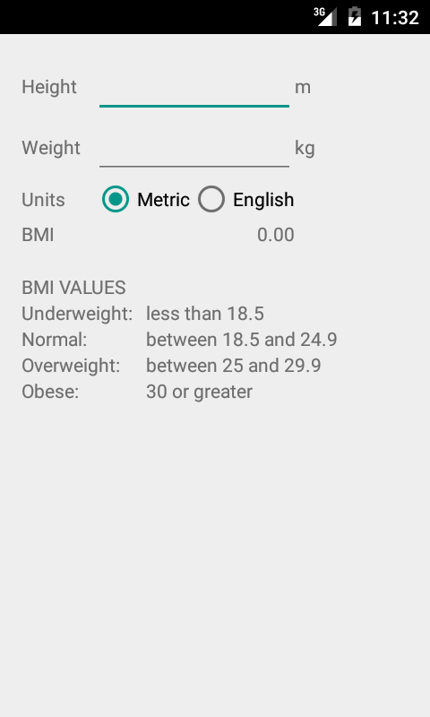

Demonstrating that 0’s do not cause a crash.  
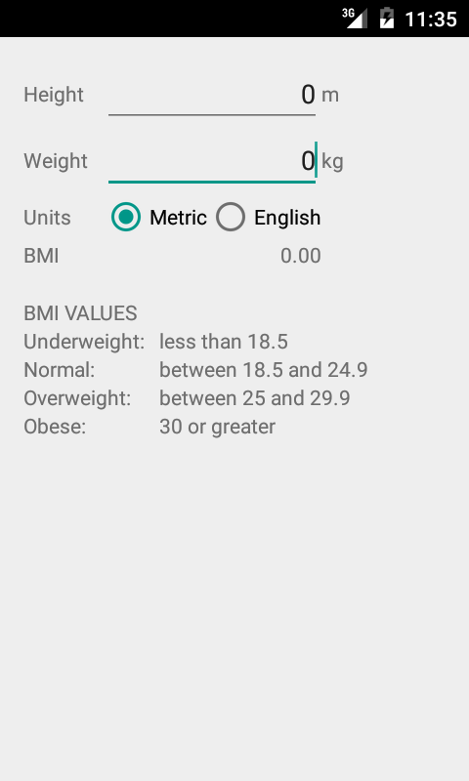

Showing that standard input works.  
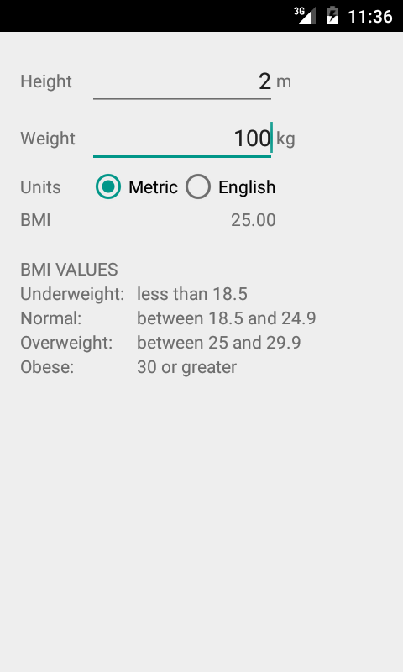

Showing that unit conversion works and is automatic.  
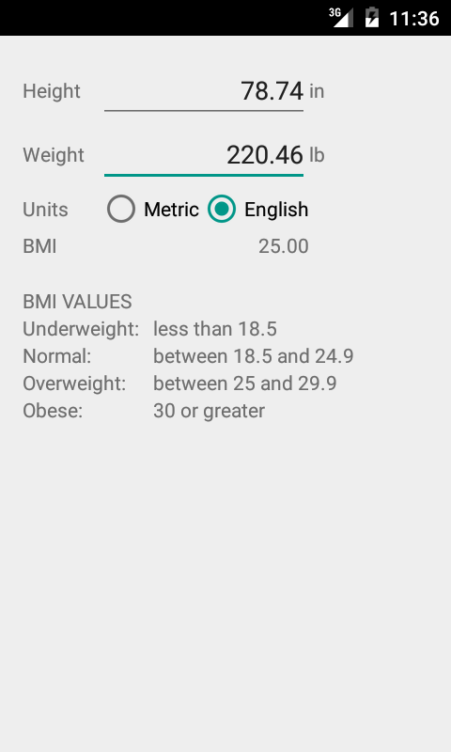

Confirming that unit conversion works in the other direction as well.  
